6. HUMAN INTERFACE DESIGN

6.1 Overview of User Interface

Based on the user’s perspective, upon accessing the website they will see the home page, where they can see the log in menu, the logo and four different menus such as classes, corporate, about us, our trainers. They will be able to browse all pages (this will be the header, visible on all pages, along with the website logo, and other information). Everyone starts as a guest-type user, and because this is a gym website, they must click on the “login/register” button to be able to use the full functionalities of the website. Of course, guest-type users are still able to view a part of the website, like classes, corporate, about us and our trainers.

Unsuccessful registrations/logins will lead to a warning. Failing to complete mandatory fields will also lead to a warning. Once logged in, the users can give us a feedback and tell us how was their training and expericence. The users will be able to book a class in “book class” page. This page is equipped with a list which contains all classes that we have. You also have to fill in your full name and your phone number. The logged user can select any classes and view the details about it. Users can see their progress in “your progress” menu. In this section , users can put information about their bodies such as kg, height, left arm cm, right arm cm, chest cm, belly cm and legs cm.

User interface share following qualities or characteristics:

Clarity: The interface avoids ambiguity by making everything clear through language, flow, hierarchy and metaphors for visual elements.

Responsiveness: This means a couple of things. First, responsiveness means speed: a good interface should not feel sluggish. Secondly, the interface should provide good feedback to the user about what’s happening and whether the user’s input is being successfully processed.

Aesthetics: While you don’t need to make an interface attractive for it to do its job, making something look good will make the time your users spend using your application more enjoyable; and happier users can only be a good thing.

Efficiency: Time is money, and a great interface should make the user more productive through shortcuts and good design.

6.2 Screen Images

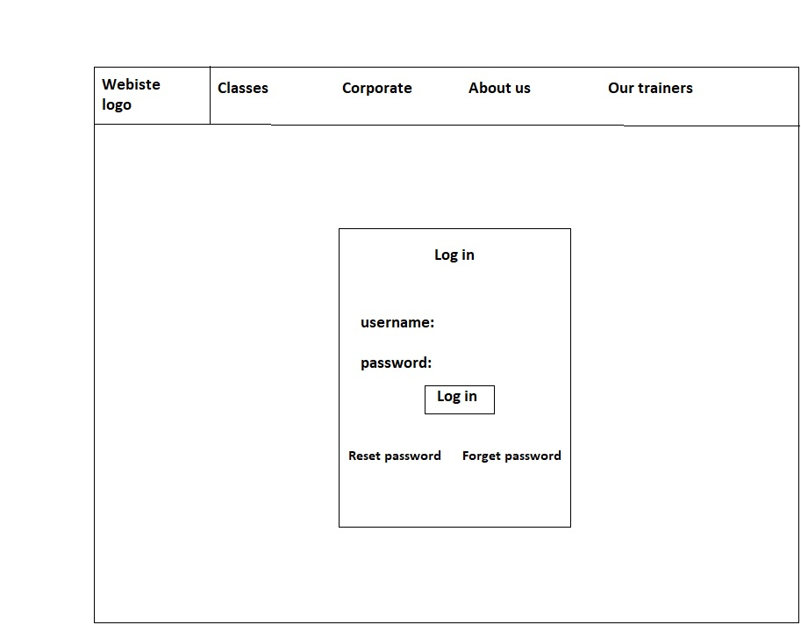

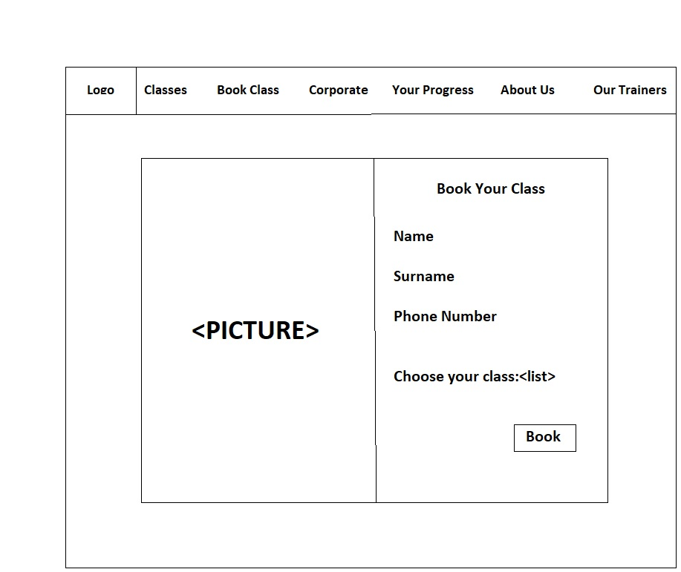

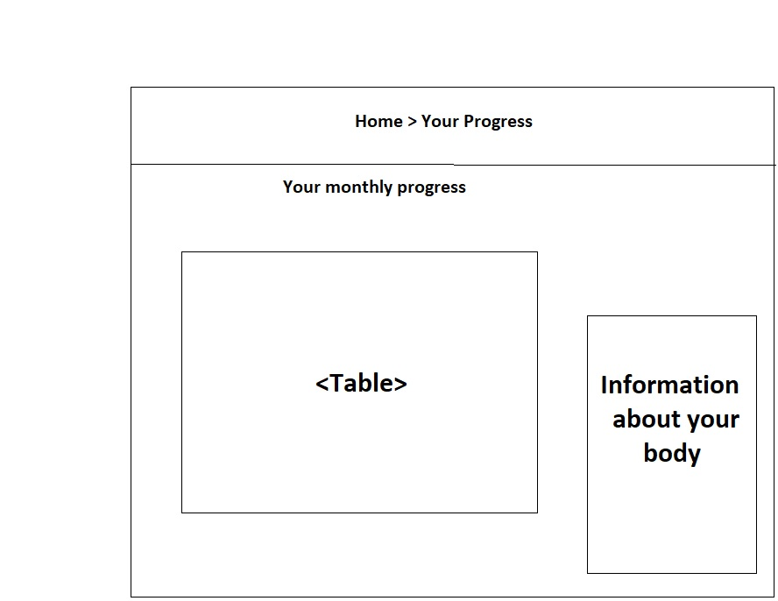

6.3 Screen Objects and Actions

Interface elements include:

⦁ Input Controls: dropdown lists, list boxes, buttons, text fields

⦁ Navigational Components: slider, search field, pagination, icons

⦁ Informational Components: icons, notifications, message boxes

7. Requirements Matrix

